Wildfire Data Finder - Project Report: Ergi Demiraj and Christopher Ouattara

Project Description
This project, Wildfire Data Finder, allows users to input a U.S. state name and a year (2020or 2021) to retrieve wildfire statistics. Specifically, it displays the number of fires and the number of acres burned for that location and time. The program uses Python, basic data structures, and object-oriented programming to organize and search wildfire data efficiently.
Significance of the Project
Wildfires are a major environmental and safety concern in the United States. Accessing wildfire history by state and year can help researchers, policymakers, and the public better understand wildfire patterns and risks. This project is meaningful because it provides an easy-to-use tool for retrieving important wildfire data. It also shows how computer science skills, such as data organization, searching algorithms, and user input handling, can be applied to solve real-world problems.
Usage Instructions
1. Open a terminal or command prompt.
2. Run the program by typing:
python wildfire_project.py
3. When prompted, enter a state name (e.g., Pennsylvania).
4. Enter a year, either 2020 or 2021.
5. The program will display the wildfire data for that state and year, or tell you if no data is available.
Code Structure
The project code is organized into the following parts:
1. Wildfire_Record Class
- Defines a Wildfire_Record object with attributes: state, year, fires, and acres_burned.
- Has a method display_info() to print wildfire information.
2. wildfire_data Dictionary
- Stores wildfire records with keys as a tuple (state, year) and values as Wildfire_Record objects.
- Allows fast search based on user input.
3. Inputs
- The user inputs the name of a state
- Then inputs either year 2020 or 2021
- Prints(“Invalid year input”) if it’s the wrong year
4. Program execution
- Enter state name.
- Enter 2020 or 2021 for the year.
- Combines the inputs to touple keys and seaches for the data in the dictionary.
- Prints out the data if its in the dictionary.
- or No result if its not.
Flowchart
Flowchart: Wildfire Data Finder
1. Start
2. Ask user to input state name
3. Ask user to input year
4. Search for (state, year) in the wildfire data
5. If data is found:
- Display the wildfire information (number of fires and acres burned)
6. If data is not found:
- Display "No wildfire data found."
7. End

Test Result
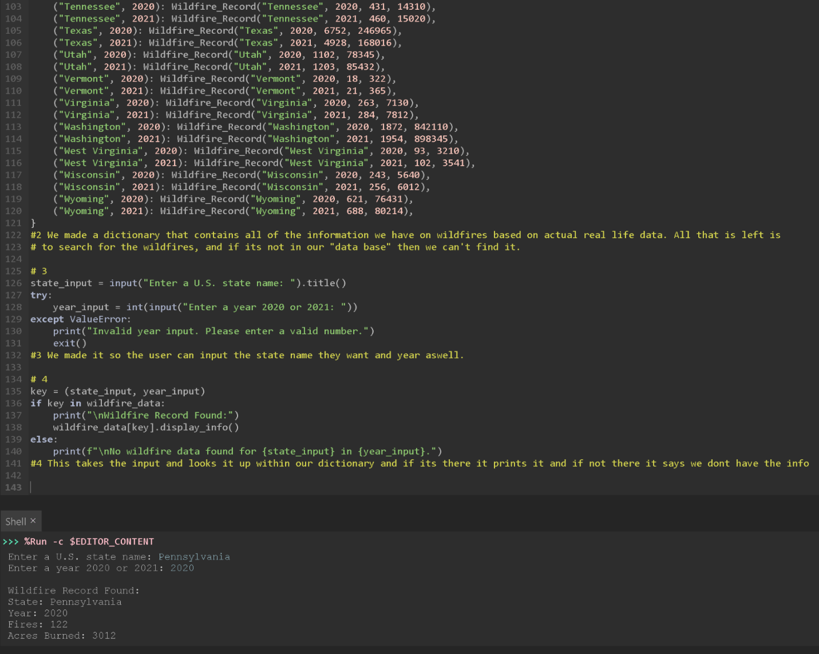
Showcasing the Achievement of Project Goals
The main goal of this project was to allow users to quickly retrieve wildfire data by entering a state name and year. This goal was successfully achieved through the following results:
- Users can easily input a state and year.
- The program searches for the wildfire data efficiently using a dictionary.
- If the data exists, it is clearly displayed with the number of fires and acres burned.
- If no data is found, the program informs the user appropriately.
- The project successfully applies Python programming skills, basic data structures, and object-oriented programming concepts to solve a real-world problem related to wildfires.
Discussion and Conclusions
Discussion:
During the development of the Wildfire Data Finder project, one of the main challenges was ensuring that the data was organized in a way that allowed for fast and easy searching. Using a dictionary with a tuple key (state, year) solved this problem efficiently. Another challenge was handling user input properly, so that small mistakes , like capitalization, would not cause search failures — this could be improved further by adding input formatting features.
Conclusions:
This project demonstrates how fundamental programming concepts like dictionaries, classes, and functions can be used to build useful real-world applications. It also shows the importance of clear user interaction and data management.
Through this project, skills such as critical thinking, problem solving, and collaborative coding were strengthened.

